WORK IN PROGRESS

Preliminary Project Plan for the IMO Single Window Project for Antigua and Barbuda

XX/XX/2017

Content

IMO Single Window Project 3

Goals and objectives of the project 3

IMO Single Window project organization 4

IMO Single Window project and system scope 5

Process and system 5

Collection of information 6

APIS and ASYCUDA systems 7

Ship reporting 7

Distribution of information 8

Main functions of the Single Window system 8

Project Constraints and Assumptions 8

Project phases 8

Project risks 10

Phases timeline and milestones 11

IMO Single Window conceptual architecture 12

Appendix I Stakeholders and key contacts list 14

Appendix II Stakeholders and document requirements 15

Appendix III 16

The Antiguan Single Window 16

Appendix III Definitions 17

Appendix IV. Other Relevant Information Resources 18

# IMO Single Window Project

**This document is a revision and a continuation of the *Concept Paper for the IMO Single Window Project for Antigua and Barbuda* and reflects the results and findings from the 1st study visit to St. Johns, Antigua from 9 to 13 October 2017.**

**Furthermore, the document outlines the preliminary project plan and the project status for the establishment of a National Maritime Single Window system in Antigua and Barbuda, based upon the Single Window of Norway, SafeSeaNet (SSNN).**

**Introduction**

The objective of the project is the implementation of a Maritime Single Window in Antigua and Barbuda. Thus, the Single Window will provide a system for maritime transport clearance, including the clearance of the ship electronically by the deadline for Public Authorities to establish systems for the electronic exchange of information by 8 April 2019, as a mandatory requirement according to the new Standard 1.3*bis* of the IMO Convention on Facilitation of International Maritime Traffic (FAL Convention).

Antigua and Barbuda and Norway are the main stakeholders for the project. IMO assumes a coordination role between Norway and Antigua and Barbuda by providing administrative assistance to the parties during the project timeline. IMO representatives are involved in the steering committee (SC), it`s meetings and monitor the project`s trajectory. Norway provides in-kind and financial support to the beneficiary country, Antigua and Barbuda.

The visit to Antigua gave the project team an opportunity to meet the stakeholders in order to discuss the scope of the project, to identify existing facilities as well as to conduct a needs assessment.

The phases of the project had been described in the previously established concept paper and are further elaborated and specified in this document. Furthermore, the document describes the proposed project organization, the participant’s roles and responsibilities.

The project is currently on time according to the tentative timeline set out in the concept paper, thus there has been no need to revise the original timeline. However, a revision is expected after the detailed project plan has been developed.

# Goals and objectives of the project

**Background information**

Maritime shipping is a business where different stakeholders, administrations and authorities contribute to its overall efficiency. Good cooperation between authorities, port management, logistic chain and private interests are essential for an efficient trade. The organization of ports varies considerably between countries, and often more than 10 different competent authorities play important roles in ports for the clearance of ships, crew, cargo and passengers.

Authorities such as customs, port administration, maritime authority, health, police, immigration, agricultural and defence related stakeholders, operate in the port environment, therefore an efficient coordination between the authorities is essential for the smooth and efficient transit of people, ships and goods through the port.

The single window concept avails the improvement in coordination between these authorities, and allows the establishment of good and efficient links between logistic chain stakeholders and private interests.

According to the Annex to the FAL Convention, a Single Window is a facility that allows submission of standardized information covered by the Convention to a single entry point. Contracting Governments should encourage public authorities to introduce arrangements to enable the submission of all the information to a "Single Window" required by the public authorities in connection with the arrival, stay and departure of ships, persons and cargo, avoiding duplication, that may serve also as a mechanism through which the public authorities communicate documents and other information covered by the FAL Convention.

In particular, a Maritime Single Window, as one of the core components of a National Single Window, simplifies and harmonises the administrative procedures applied to maritime transport by making the electronic transmission of information standard and by rationalising reporting formalities such as reporting of the ship security, ship-generated waste, dangerous goods and persons onboard. A new Recommended Practice encourages the use of the "single window" concept, to enable all the information required by public authorities in connection with the arrival, stay and departure of ships, persons and cargo, to be submitted via a single portal without duplication.

# IMO Single Window Project Organization

There are three primary parties in the project; Antigua and Barbuda, Norway and the IMO. These parties will undertake the following principal roles and responsibilities.

|  |  |  |
| --- | --- | --- |
| **Stakeholder** | **Role** | **Responsibility** |
| Antigua and Barbuda | Beneficiary country | * Domestic implementation MSW   + Operational   + Legal   + Technical * Coordination of local activities and secondary stakeholders |
| Norway | Donor country | * In-kind, financial support * Technical support |
| IMO | Coordinator | * Project coordinator * Administrative support |

These parties will be represented in the Steering Committee (SC) of the project.

Antigua and Barbuda will have several principal and secondary stakeholders benefitting from the project such as Port, Immigration, Customs and ship agents to name a few. Theproject team(s) will comprise people from the principal stakeholders and secondary stakeholders as needed.

The current proposal is to establish two working groups in the project;

* Technical Working Group (TWG), comprised of relevant representatives of IMO, Norway, and Antigua and Barbuda. TWG shall deal with technical aspects as an independent group before the system is operational for testing, and it would report on the progress of the project to the SC.
* Operational Working Group (OWG), comprised of relevant stakeholders in Antigua under the direction of ADOMS. The OWG will be the responsible body to test and implement the MSW in Antigua and Barbuda. The progress made of the project will be reported to the SC.

IMO has prepared the mandate and Terms of Reference of the two working groups, subject to further consideration of the SC .

# IMO Single Window project and system scope

The functionalities to be implemented in the MSW are well defined and communicated to the stakeholders in Antigua and Barbuda. The boundaries of the project are tied to the scope of reporting requirements in the FAL Convention. These system boundaries are described in this section.

### Process and system

Maritime transport is one of several transport modes; therefore it is important to note that this project aims at developing a National Maritime Single Window system solution for *maritime transport domain*. The term[1] National Maritime Single Window system (NMSW) is in this context, relates to the only single window for the maritime transport nationally. This also implies that all single window operations are performed through one NMSW.

In the NMSW there are two main stakeholder segments; ***offshore*** and ***onshore***. Typical offshore stakeholders would be the master of a ship obligated to report ship movement to and from a port to the relevant authorities (data provider). A ship agent can under certain circumstances act on the master`s behalf. Onshore stakeholders, on the other hand, comprise ports and authorities such as Customs and Immigration which are entitled to receive any relevant information that has been transmitted from the ship master or agent (data provider).

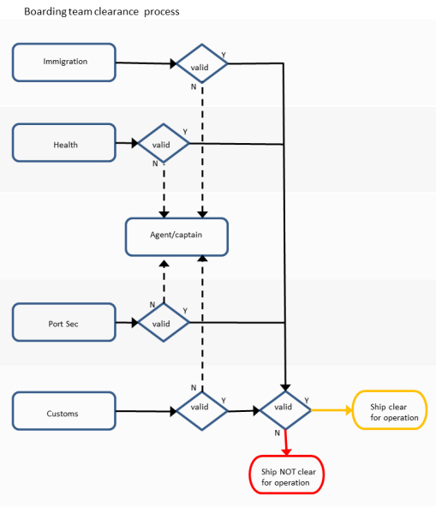The authorities might also grant clearance to the ships before entering or leaving national waters, as well as clearance for a ship to berth or leave.

Figure 1 Clearance Process in Antigua

The FAL Convention define the maximum amount of clearance information that may be required before a ship can go to berth. Normally, a ship clearance means that cargo can be offloaded to the quay side and that passenger may disembark for immigration control upon arrival; whereas for departure, the ship clearance implies that the vessel can leave her berth.

In Antigua and Barbuda, the clearance process is mainly done through an established process on arrival, as illustrated in Figure 1. Representatives from the authorities (Boarding Team) board the ship and manually check, and approve the required documentation provided by the master of the ship. After the document approval, the ship is cleared for operations in port.

Based upon the above, the scope of the Single Window system to be implemented comprises the following elements:

* The collection of information through the National Maritime Single Window
* The distribution of the information to the relevant stakeholders
* Additional functions of the Single Window system

### Collection of information

The information collection deals with the provisions concerning the formalities required by the public authorities when a ship is calling at or departing from a port in Antigua and Barbuda.

Findings during the visit to Antigua revealed that the stakeholders require a comprehensive amount of information from arriving and departing ships, exceeding required limits as per the FAL convention. Several of the required information elements are duplicated on various forms, and some of the information collected is outside of the scope of the system that will be implemented in this project.

A simplified process[2] chart of the collection process is visualized in the picture below:

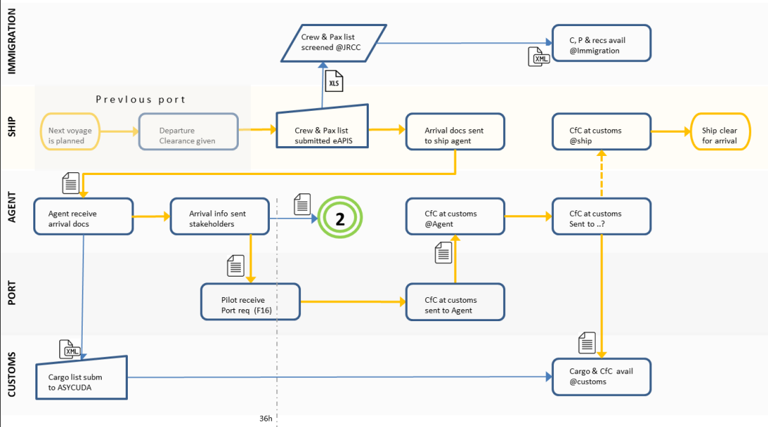

Figure 2 Ship arrival; information and paper flow

The picture only depicts the process and document flow on ship`s arrival. The extent of papers/forms required can be found in “DR” contained in Appendix II.

It is clear that the MSW of Antigua in this project, will not cover the collection of all documentation that the authorities involved require today. The required information to be reported in the proposed system will be limited to the reporting requirements in the FAL Convention.

The Maritime Single Window to be implemented in Antigua and Barbuda is therefore not foreseen to handle any electronic transmission other than those covered by the following FAL forms[3]:

* General Declaration FAL Form 1;
* Cargo Declaration FAL Form 2;
* Ship’s Stores Declaration FAL Form 3;
* Crew’s Effects Declaration FAL Form 4;
* Crew List FAL Form 5;
* Passenger List FAL Form 6; and
* Dangerous Goods Manifest FAL Form 7

### APIS and ASYCUDA systems

Antigua and Barbuda is a member of the Caribbean Community (CARICOM) an organization of the Caribbean nations. CARICOM has established an Advance Passenger Information System (APIS). Any vessel (or flight) calling at a member State is required to submit Advance Passenger Information prior to arrival in CARICOM region and upon departure from a CARICOM port at least 24 hours in advance.

The Joint Regional Communications Centre (JRCC) is the central clearing house for the Advance Passenger Information (API) and acts and on behalf of individual CARICOM Member States for the purpose of pre-screening of passengers from air and sea carriers traversing the Region. The outcomes of this screening and passenger information are submitted to the national immigration department (depicted).

Similar arrangements to the APIS process are planned for cargo information.

In a similar, but parallel process, Customs declarations for ships arriving in Antigua are done through ASYCUDA system (depicted). The ASYCUDA system is operated by the Customs authorities in Antigua.

The two above mentions systems (APIS and ASYCUDA) have characteristics of a Single Window concept. This needs to be taken into account when implementing the MSW in Antigua and Barbuda to prevent or reduce the duplication of reporting.

Further investigations and discussions are needed.

### Ship reporting

Basically, all ship reportings in Antigua and Barbuda are done through the ship agent. However, it is not clear yet, whether the ship agent reports passenger information into the APIS system.

### Distribution of information

The Single Window in Antigua and Barbuda will, in principal, be able to provide relevant information on ship reporting to any stakeholder with the appropriate access to the Single Window system. Initially, the system will be setup with access to relevant information to the following onshore stakeholders:

* Immigration;
* Customs;
* Maritime Authorities;
* Port Authorities;
* Health Authorities;

The above mentioned stakeholders will access the relevant information regarding a ship call after logging in to the central system.

### Main functions of the Single Window system

The scope of the main functionalities of the system is described under the section *IMO Single Window architecture*.

### Project Constraints and Assumptions

Project constraints need further elaboration. However, the scope is clear and the constraints aspects will be kept within the system and the project scope.

From a technical point of view, the project assumes that Antigua and Barbuda will provide the facilities for the Single Window system to be installed in a designated and appropriate environment i.e. it will provide the necessary hardware, power, network connectivity, software platform etc.

Furthermore, the project assumes that Antigua and Barbuda will make appropriate human resources available for the project components (SC, TWG and OWG) to be able to implement the MSW both at operational and legal ends.

# Project phases

When implementing a Single Window, challenges related to the technical aspects of the systems, the organizational and inter-organizational, managerial, financial, political, legal, national and international settings may be faced

Persons in charge, and persons working on the planning, implementing and overseeing of the Single Window project need to manage many aspects of the project and create an environment in which the project can successfully implemented.

The various phases described below have been partly accomplished, but the remaining phases are subject to revision when the project plan is more mature.

1. **Preliminary study**

The preliminary study was conducted during the visit to Antigua in a series of meetings with the key stakeholders. The main objective was to agree upon the concept of the MSW.

***Deliverables***: Clear Scope of Work, Stakeholders list

1. **Feasibility analysis**

The feasibility discussion was conducted during the visit to Antigua in a series of meetings with the key stakeholders. The meetings elaborated on the scope, identified existing systems, elaborated on the user needs, discussed the required resources (financial, human, technical) and identified project/system risks.

The feasibility discussion is still ongoing, and it is important that the OWG assesses the options available and their impact on systems and operations in Antigua and Barbuda.

***Deliverables***: Mandate, Project group, Status of Antigua and Barbuda,

***Deliverables TBD***: Risk assessment.

1. **Detailed project/master plan**

Based upon the results of the deliverables and discussions, a detailed project plan will be developed that will describe the scope and objectives of the project, the key system functionalities and requirements, standards to be used, information strategy, planning for training and a detailed plan for development.

The detailed project/master plan will be an important project management tool to plan, execute, monitor, evaluate, and adjust the project implementation.

***Deliverables:*** Project/Master plan, detailed activities and adjusted timeline

1. **Technical development/deployment**

The deployment phase focuses on the establishment and development of the system components and functionality according to the detailed project/master plan.

***Deliverables:*** Pilot Maritime Single Window implementation for Antigua and Barbuda.

1. **Implementation (installation/training/information)**

In parallel with technical development phase, the necessary information and training of the operational users of the system will be conducted.

***Deliverables:*** Training, Information, Operational Single Window for Antigua and Barbuda.

1. **Feedback (Collecting lessons learned)**

The objective of this phase is to collect the experiences gained and lessons learned of the project and to prepare some input to the IMO through submitting documents to the next sessions of the FAL Committee containing those aspects to be taken into account for other Member States whilst establishing their MSWs.

***Deliverables***: Report lessons learned.

# Phases timeline and milestones

Below is an updated version of the indicative high level schedule and milestones[4] for the phases of the proposed project. The ultimate goal is to put into service an operational National Maritime Single Window system in Antigua and Barbuda by April 2019.

The initial task of the writing of the concept paper was accomplished in July. The visit to Antigua and kick-off meeting was carried out according to the plan. The clear scope of work has been communicated and agreed upon. A project organisation has been proposed, as well.

The project is currently on time according to the tentative timeline which had been set out in the concept paper, thus there has been no need to revise the original timeline. However, a revision is expected after the detailed project plan has been developed.

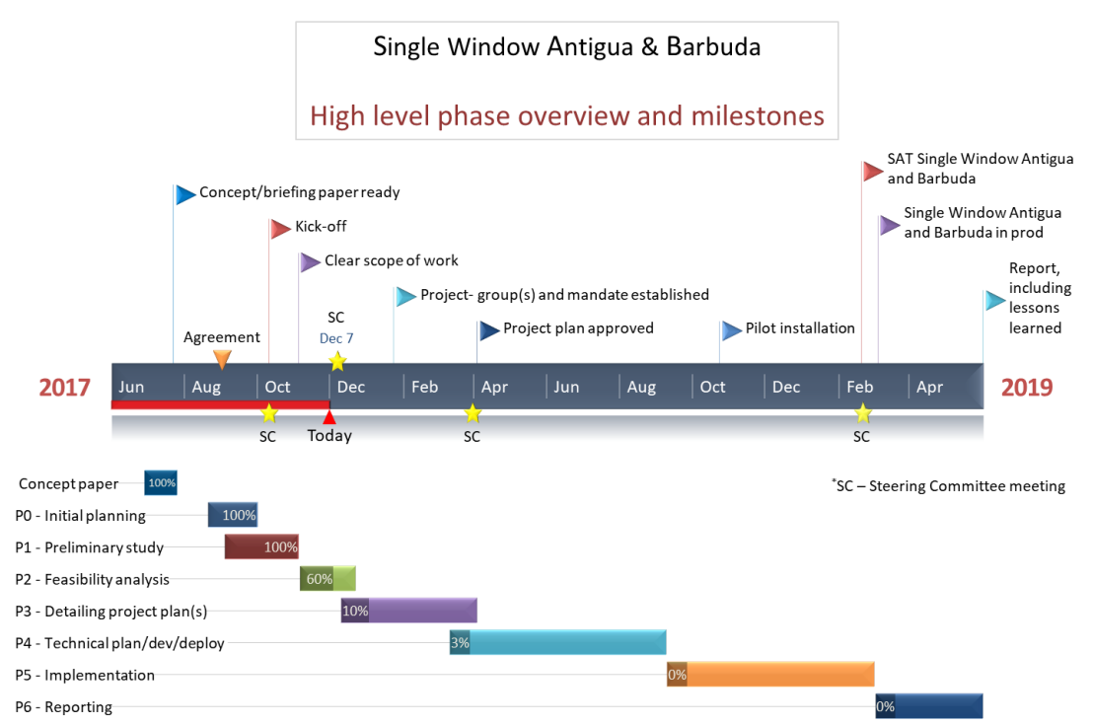

Figure 3 High level schedule and milestones (updated 30.11.17)

The human and operational aspects of the implementation are very important when establishing a Single Window system. The ambition is therefore to have a pilot installation of the system in Antigua and Barbuda by the fourth quarter of 2018, allowing time for training, communication and administrative/operational/technical knowledge ahead of putting the system in operation in March 2019.

Around the end of first quarter of 2019 the Single Window in Antigua and Barbuda will go into operation.Below there are a textual overview of indicative dates and durations for the different phases and millstones.

|  |  |  |  |
| --- | --- | --- | --- |
| **Task(s)** | | |  |
| **Duration (days)** | **Start Date** | **End Date** | **Description** |
| 18 | 06.29.2017 | 07.24.2017 | Concept paper |
| 30 | 08.21.2017 | 09.29.2017 | P0 - Initial planning |
| 45 | 09.04.2017 | 11.03.2017 | P1 - Preliminary study |
| 33 | 11.06.2017 | 12.20.2017 | P2 - Feasibility analysis |
| 81 | 12.11.2017 | 04.02.2018 | P3 - Detailing project plan(s) |
| 130 | 03.12.2018 | 09.07.2018 | P4 - Technical plan/dev/deploy |
| 125 | 09.10.2018 | 03.01.2019 | P5 - Implementation |
| 65 | 03.04.2019 | 05.31.2019 | P6 - Reporting |

|  |  |
| --- | --- |
| **Milestone(s)** | |
| **Date** | **Description** |
| 07.21.2017 | Concept/briefing paper ready |
| 09.01.2017 | Agreement |
| 10.09.2017 | Kick-off |
| 10.10.2017 | Steering Committee meeting |
| 11.03.2017 | Clear scope of work |
| 12.07.2017 | Steering Committee meeting |
| 01.22.2018 | Project- group(s) and mandate established |
| 03.30.2018 | Steering Committee meeting |
| 04.02.2018 | Project plan approved |
| 10.22.2018 | Pilot installation |
| 02.18.2019 | SAT Single Window Antigua and Barbuda |
| 02.20.2019 | Steering Committee meeting |
| 03.04.2019 | Single Window Antigua and Barbuda in prod |
| 05.31.2019 | Report, including lessons learned |

**IMO Single Window Conceptual Architecture**

The system depicted below represents a conceptual architectural model that defines the structure and behaviour of the Single Window. This model assumes that a single authority has the responsibility to operate the system that receives information electronically via the Single Window and thereby disseminates this information to all relevant stakeholders.

The conceptual model illustrates that the NMSW consists an environment whereby ship data providers can submit information electronically either through a user interface or a system-to-system interface. The information is digitized, and the individual data elements will be submitted once only.

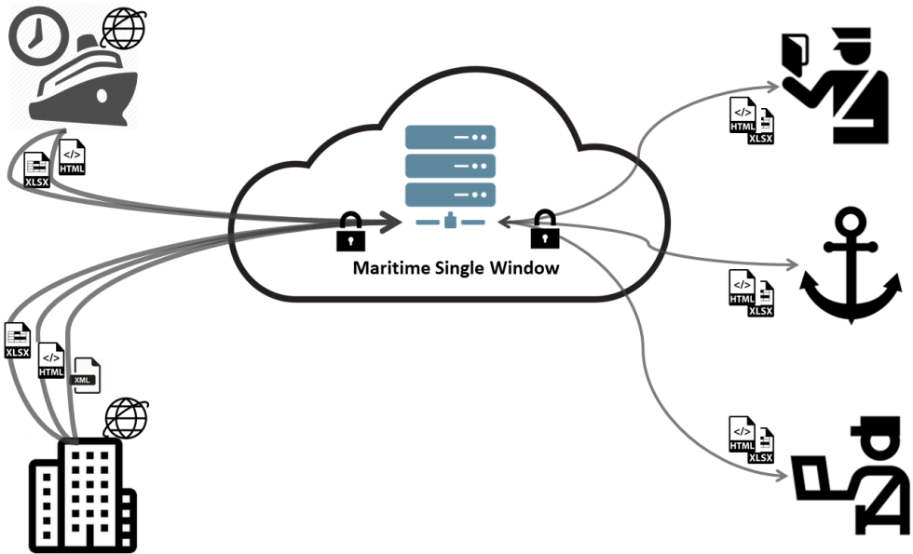

Figure 4 Single Window conceptual architecture

Within this general system configuration there are many possible ways of how to define the architecture of a NMSW depending upon each state own requirements and conditions.

The figure illustrates the information flows which take place within the NMSW, such as:

* the submission of information by the shipping industry (e.g. ship master or agent) and the receipt of decisions from authorities;
* the distribution of the received information to the authorities and the submission of their decisions to the shipping industry

Due to the rapid evolution of technologies during the last decade and the exponential rise in the possibilities of exchange and storage, it is recommended to have an open architectural vision geared to the future. Central topics:

* modular design and standardized interfaces;
* ensure interconnection with ships/agent for reporting;
* ensure interconnection with authorities and entities having autonomous systems;
* exchange with stakeholders/users not having (own) computer systems;
* compensate for the absence, the poor quality or the high costs of telecom links;
* ensure continuity of the service

The FAL Convention encourages the use of modern information and communication technology and, in particular, electronic exchange of information, including electronic data interchange (EDI), to transmit information related to maritime transport.

Requirements for EDI will be evaluated in the Feasibility analysis (Phase 2). The preliminary assumption is therefore that the identified stakeholders will only provide and access relevant information through the NMSW web interface.

# Appendix I Stakeholders and Key Contacts List

|  |  |  |  |
| --- | --- | --- | --- |
| **Department of Marine Services and Merchant Shipping (ADOMS)** | | | |
|  | | | |
| **Key Contact(s)** | **Position** | **Phone #** | **E-Mail** |
| Mr. Wayne Mykoo | Deputy Director Maritime Affairs and External Relations | +1(268)464-2468 | [wmykoo@abregistry.ag](mailto:wmykoo@abregistry.ag) |
|  |  |  |  |
| **Port Authority** | | | |
|  | | | |
| **Key Contact(s)** | **Position** | **Phone #** | **E-Mail** |
| Mr. Curtis Dennie | Operations Manager | 1268-772-6692 | [portoperationsmanager@gmail.com](mailto:portoperationsmanager@gmail.com) |
|  |  |  |  |
| **Customs and Excise Division** | | | |
|  | | | |
| **Key Contact(s)** | **Position** | **Phone #** | **E-Mail** |
| TBD |  |  |  |
|  |  |  |  |
| **Immigration Department** | | | |
|  | | | |
| **Key Contact(s)** | **Position** | **Phone #** | **E-Mail** |
| TBD |  |  |  |
|  |  |  |  |
| **Central Board of Health** | | | |
|  | | | |
| **Key Contact(s)** | **Position** | **Phone #** | **E-Mail** |
| TBD |  |  |  |

# Appendix II Stakeholders and Document Requirements

|  |  |
| --- | --- |
| **Customs and Excise** | Cargo Manifest Boarding Book Form List of unmanifested Cargo Narcotics List Nil Declaration Arrival Crew List Last 10 Port of Call Ship Stores Declaration Crews Effects Declaration Clearance Certificate from last port Clearance Certificate for Departure Ship`s Particulars Export Document |
| **Immigration** | Port Officer`s Return Declaration of Health Departure Crew List (4 copies, exceptional) Arrival Crew List Last 10 Ports of Call Ship Particulars |
| **Port & Port Security** | Port officer`s Return ISPS Certificate (1st arrival) Arrival Crew List Narcotics Nil List  Ships Particular Last Ten Port Calls |
| **Health Authority** | Declaration of Health Ship Sanitation Control Certificate Waste declaration |

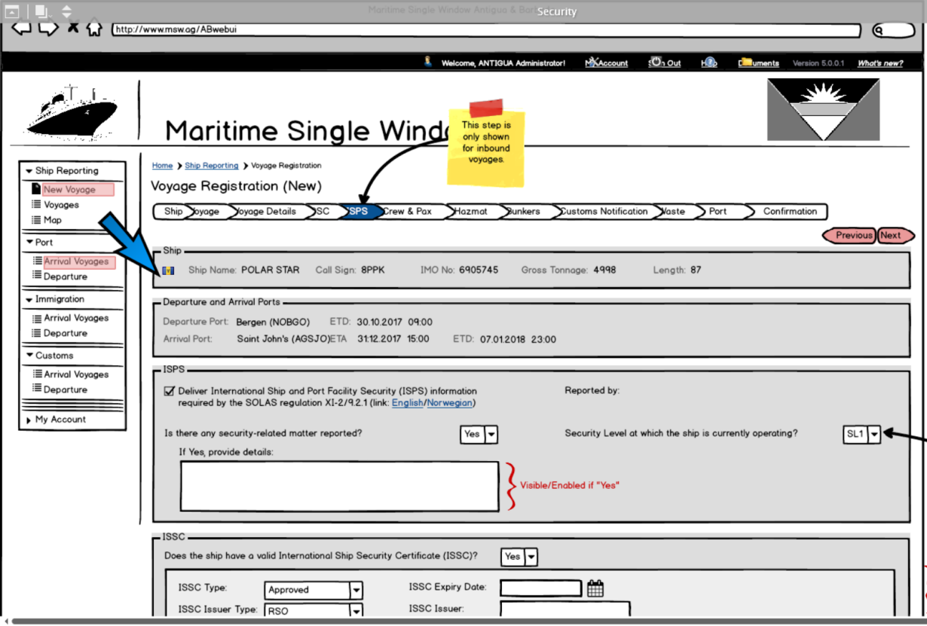

# Appendix III Definitions

**Clearance**:

The accomplishment of formalities necessary to permit:

1. goods to enter a country, to be exported or to be placed under another Customs procedure;
2. persons to enter or leave the territory of a State; and
3. a ship to enter or depart the territorial waters of a state or a port within the territory of a State.

The scope of this proposal take into consideration only ship clearance which is the process undertaken by an authority for the purpose of determining if a ship may enter or leave a port of the state.

**Data provider**:

A person and/or an organisation responsible for supplying information to the NMSW,

**National Maritime Single Window (NMSW)**:

An environment for collection, dissemination and exchange of vessel reporting information with a structured and commonly defined data structure, rules and management of access rights, which are in accordance with relevant international, national and local legal requirements.

**NMSW authority**:

The competent authority or body designated by the state to implement and setting up and operation of the NMSW.

**Relevant authority**:

A national or local authority which is involved in the clearance of ships arriving at or departing from a port or has legal rights to access the information collected by the NMSW.

# Appendix IV. Other Relevant Information Resources

* Final reports of the FAL Committee (FAL 39/16; FAL 40/19; FAL 41/17)
* Guidelines for setting up a single window system in maritime transport (FAL.5/Circ.36)
* IMO FAL Compendium on Facilitation and Electronic Business (FAL.5/Circ.35/Rev.1)
* Recommendation and Guidelines on establishing a Single Window   
  (Rec.33 by UN/CEFACT)

1. The term Ship Single Window are sometimes used.
2. Note: The process chart is still to be verified by the primary stakeholders.
3. <http://www.imo.org/en/OurWork/Facilitation/FormsCertificates/Pages/Default.aspx>
4. Introduced in the Concept paper.